Detailed Design - Bagheera
GUI System for Managing and Visualizing the PANTHER Model
Course: Final Project
Organizational Partner: Sheba Medical Center

1. Project Scope and Requirements
Bagheera is an interface layer designed to bridge the gap between advanced computational pathology models and clinical workflows. The system provides a Graphical User Interface (GUI) for the PANTHER (Pathology Nuclei-aware Transformer) model.
The PANTHER model performs unsupervised slide representation learning by identifying distinct morphological prototypes. Currently, this capability exists as command-line scripts. Bagheera aims to transform these raw morphological prototypes into a navigable, visual workspace that allows clinicians to validate and utilize findings without technical friction.
The system focuses on :
- Dataset Management: Uploading and managing Whole-Slide Images (WSI) in TIFF, H5, and PT formats.
- Inference Execution: Initiating PANTHER inference jobs via a FIFO queue management system.
- Cluster Visualization: Displaying morphological prototypes and representative image patches.
- Semantic Labeling: Allowing pathologists to assign biological labels to unsupervised clusters.
- Annotation System: Supporting slide-level and cluster-level clinical notes.

2. Logical Architecture & Modular Decomposition
The system is designed with a modular, component-based architecture to allow flexibility and separation of concerns. It utilizes a Client-Server architecture.

2.1 Core Modules
- Client (Frontend/View): Built with React, providing the interactive slide viewer, patch gallery, and dashboard.
- API Layer (Backend/Controller): Built with Python (Flask/FastAPI), handling web routing, queue management, and database operations .Model Integration (Worker): A dedicated Python module that abstracts the command-line scripts to interface with the existing Harvard PANTHER codebase and execute PyTorch tensors.

2.2 Cohesion, Coupling, and Interface Contracts
To maintain high maintainability, the system enforces loose coupling and high cohesion:
- High Cohesion: The Python API is strictly responsible for web routing and database operations. It doesn’t perform any heavy data processing. Conversely, the PANTHER Worker is entirely dedicated to executing the inference pipeline and processing large slides, unaware of HTTP requests.
- Loose Coupling via Interface Contracts: The API and the PANTHER Worker do not communicate directly. They are decoupled using the SQL Database Queue as their strict interface contract. The API writes a standard job payload to the database, and the Worker reads it. If the Worker crashes due to a GPU memory error, the API remains fully responsive to the user.
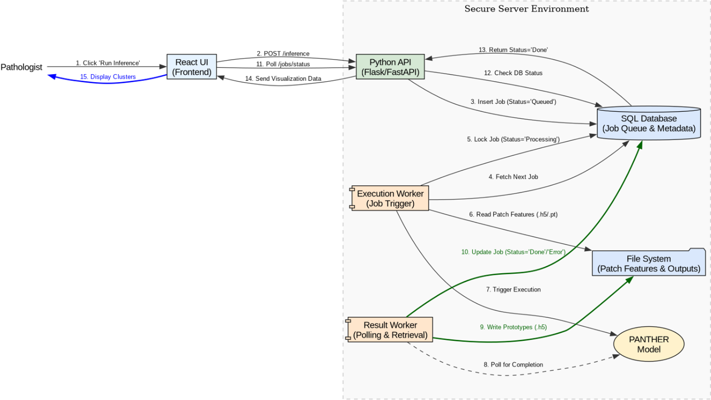

2.3 REST API Specification [PENDING SHEBA COORDINATION]
The communication between the React client (Frontend) and the Python backend (FastAPI/Flask) is governed by a strict RESTful API interface.
Coordination Note: The exact data types for identifiers (e.g., whether a job_id or cluster_id is an Integer, UUID, or String Hash) are abstracted below and depend on the final database schema agreed upon with the Sheba Medical Center data science team.
HTTP Method | Endpoint | Description | Expected Request Payload | Expected Response (Success)
POST | /api/v1/inference | Initiates a new PANTHER inference job (UC1) | {"dataset_id": "string", "num_clusters": "number"} | 200 OK: {"job_id": "string (ID)", "status": "Queued"}
GET | /api/v1/jobs/{job_id}/status | Polls the current status of an inference job | None | 200 OK: {"job_id": "string (ID)", "status": "string", "progress": "number"}
GET | /api/v1/visualization/{job_id} | Retrieves generated morphological prototypes and patch paths (UC3) | None | 200 OK: {"clusters": [{"cluster_id": "string (ID)", "patches": ["url_string"]}]}
POST | /api/v1/annotations | Saves a clinical annotation to a slide/cluster (UC2) | {"target_id": "string (ID)", "target_type": "string", "note": "string"} | 201 Created: {"annotation_id": "string (ID)", "message": "Saved"}
PUT | /api/v1/labels/{cluster_id} | Assigns a semantic biological label to a cluster (UC4) | {"label": "string", "confidence": "number"} | 200 OK: {"cluster_id": "string (ID)", "label": "string"}
POST | /api/v1/datasets/upload | Uploads a new dataset to the secure file system (UC6) | multipart/form-data (File upload) | 202 Accepted: {"dataset_id": "string (ID)", "message": "Upload successful"

3. Physical Deployment and Infrastructure
The system is designed for On-Premise Deployment to comply with hospital security requirements. It executes strictly within the hospital's secure internal network and does not require external internet access.
Crucially, "on-premise" does not restrict the application to a single local machine. The backend API, the relational database, heavy WSI files (required for the frontend visualizer), and pre-extracted Patch Feature Vectors (required for model inference). The frontend React application will be served over the hospital's Intranet. This ensures that the GUI, generated cluster visualizations, and clinical annotations are readily accessible to authorized pathologists concurrently across the Sheba Medical Center network, without transmitting patient data outside the infrastructure.

4. Data Architecture and Schema Design [PENDING SHEBA COORDINATION]

The system is designed to implement a strict separation of concerns between structured metadata and heavy computational data. To ensure high system performance and prevent database bloat, large Whole-Slide Images (WSI) and pre-extracted Patch Feature Vectors (.h5/.pt) require storage optimized for heavy files.

Coordination Note: The exact physical storage mechanism for these heavy files (e.g., local Linux network drives, existing hospital object storage, or PACS integration) is pending confirmation with Sheba's data science teams.

4.1 Relational Database Integration [PENDING SHEBA COORDINATION]
For structured data and operational records, we will utilize a relational SQL database to ensure data integrity.
Coordination Note: The exact mapping of the tables below is pending iterative technical discovery meetings with Sheba's data science team to review their existing schema capabilities and integration points.

If the required capabilities do not currently exist, we propose adding:

- Job Management: Tables to support a FIFO queue, tracking job status (Queued, Processing, Done, Error) and priority.
- Semantic Labels: Storage linking generated morphological clusters to human-readable biological names assigned by pathologists.
- Clinical Annotations: Capability to store text-based clinical observations.

5. Algorithm Description: Queue Management
To ensure reliability and manage GPU resources for the heavy PANTHER model, the system relies on an Inference Queue Management algorithm.
5.1 Plain English Description
- Initialize a FIFO (First-In, First-Out) queue in the database.
- When a user initiates an inference, place the job in the queue with a "Queued" status.
- An Execution Worker continuously loops to check for pending jobs.
- It selects the first "Queued" job, locks it by updating the status to "Processing", reads the required Patch Feature Vectors from the file system, and triggers the PANTHER model.
- The Execution Worker immediately frees itself to fetch the next queued job.
- A parallel Result Worker repeatedly polls the active PANTHER processes to monitor for completion.
- Once the PANTHER model natively finishes writing the Morphological Prototypes to the disk, the Result Worker updates the database job status to "Done".

5.2 Pseudocode
// Process 1: Execution Worker (Triggering)
function executionWorkerLoop(database, fileSystem):
while true:
job = database.getNextJob(status="Queued", orderBy="priority DESC")
if not job:
wait()
continue

job.setStatus("Processing")
vectors = fileSystem.readFeatureVectors(job.datasetId)

try:
triggerPantherModelAsync(vectors) // Fires execution and releases worker
catch errors:
job.setStatus("Error")
logError(errors)

// Process 2: Result Worker (Status Manager)
function resultWorkerLoop(database, fileSystem):
while true:
activeJobs = database.getJobs(status="Processing")
for job in activeJobs:
if isPantherProcessFinished(job.processId):
if fileSystem.verifyPrototypesExist(job.outputId):
job.setStatus("Done")
else:
job.setStatus("Error")

Sequence Diagram:

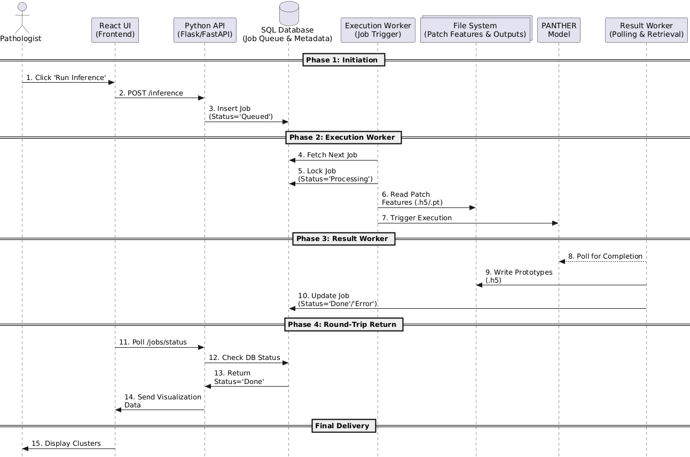
5.3 Complexity Analysis
- Time Complexity: The Result Worker polling mechanism aims for O(k) time per cycle, where k is the number of currently "Processing" jobs being queried in the database.
- Space Complexity: O(1) auxiliary space for the queue managers. By decoupling the Execution and Result workers, the architectural goal is to prevent memory bottlenecking. The queue management scripts will only hold lightweight job metadata (strings/IDs) in active memory, explicitly avoiding the loading of heavy vector data.

6. Use Case Analysis and System Interactions
The system encompasses six primary use cases focused on making the model accessible without programming knowledge.
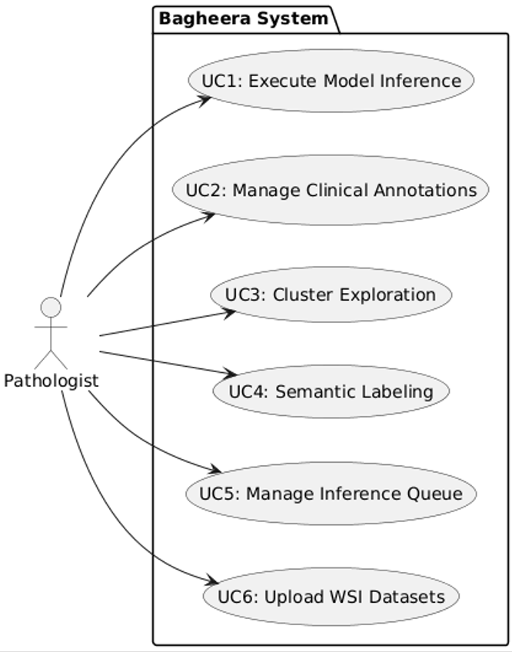
UC Diagram

- UC1: Execute Model Inference. A pathologist initiates the PANTHER inference job, which enters the system's FIFO queue.
- UC2: Manage Clinical Annotations. Pathologists can attach saved text annotations (e.g., "High grade dysplasia") to specific regions or clusters.
- UC3: Cluster Exploration. Pathologists navigate clusters and scroll through representative patch galleries to assess morphology.
- UC4: Semantic Labeling. Pathologists translate AI findings by assigning biological medical terminology to clusters.
- UC5: Manage Inference Queue. Pathologists view the dashboard and drag critical jobs to the top of the queue to update execution priority.
- UC6: Upload Datasets. Users upload new slide datasets (TIFF, H5) into the system for analysis.

7. Programming Languages, Tools, and Standards
- Programming Languages & Frameworks: The backend system shall be implemented entirely in Python using Flask or FastAPI. The frontend utilizes React (JavaScript / TypeScript).
- Version Control: Git shall be used for version control of the entire project. Feature branches and descriptive commit messages will be enforced.
- Coding Standards: Code shall be documented using standard inline comments to improve readability and maintainability.
- Mentoring & Code Reviews: The academic supervisor and the lab researchers will oversee methodology, and reviews will take place iteratively alongside the data science team.

8. Testing Framework and Failure Modes
Testing will be modularized to separate core system logic from hardware-dependent inference tasks.

- API & System Tests (Unit/Integration): Testing backend routing logic, database CRUD operations, and the FIFO queue priority algorithms.
- Manual Validation: UI/UX testing to ensure functionality is available without programming knowledge.

8.1 Test Case (TC) Trace Table
Tests will be documented using the following trace table format:
TC ID | Module | Scenario | Pre-Condition | Steps to Execute | Expected Result
TC-01 | Queue | Job Priority Reorder | 3 jobs in "Queued" status | 1. Drag Job 3 to top.  2. Wait for Worker. | System updates execution order. Job 3 processes first.
TC-02 | Worker | Job Lock | Job 1 is "Processing"  +1 | 1. Attempt to drag Job 1 in UI. | Job is locked and cannot be moved.  +1
TC-03 | API | Invalid Upload | User selects .txt file | 1. Upload file. | Validation fails. Only TIFF/H5 accepted.
TC-04 | Worker | Hardware Busy | GPU resources in use | 1. Click "Run Inference". | Job remains in "Queued" status until resources free.

9. Monitoring, Troubleshooting, and Integration
To prioritize maintainability and reliability :

- User-Facing Monitoring: The primary interface will be the GUI's "Job Status" dashboard, displaying inference job start times, completion times, execution status, and warning messages.

- System Troubleshooting: The system shall utilize standard Python file logging to record non-critical errors. This allows the system to continue operating without requiring a full manual restart when isolated issues occur.

10. Documentation Templates and Project Outcomes
10.1 Documentation Artifacts
To streamline the delivery, the team will produce fixed templates for:
- Requirements Documentation: Detailing functional and technical requirements.
- Design Documents: Including system architecture and use cases.
- User Manual: End-user documentation explaining interface commands for the pathologists.
- Final Project Report: Summarizing project timeline, achievements, and challenges.

11. Gantt Plan (Timeline) Timeline Overview:
March: Project Kick-off and Implementation start.
June: Final Delivery (End of Semester B).
Phases:

- Phase 1: Infrastructure & "Hello World" (Weeks 1-3 | Mar 1 - Mar 21)
Goal: Successfully run the PANTHER model on dummy patch feature vectors on the hospital GPU server.
- Phase 2: Core Backend & DB Integration (Weeks 4-7 | Mar 22 - Apr 18)
Goal: Implement the decoupled asynchronous polling workers, connect to the hospital database, and stream WSI patches to the React client.
- Phase 3: Advanced Visualization - "Bagheera" Core (Weeks 8-11 | Apr 19 - May 16)
Goal: Full implementation of Cluster Visualization, Heatmaps, and the "Pop-out" feature.
- Phase 4: Researcher Tools & MVP Polish (Weeks 12-14 | May 17 - June 10)
Goal: Enable Semantic Labeling and Annotations.
- Phase 5: Final Testing & Submission (Weeks 15-16 | June 11 - June 30)
Goal: System stress testing, final debugging, and project submission.

Note on Planning & Flexibility:
The effort estimations and timeline presented above are approximations based on our current analysis of the requirements and infrastructure. As this project involves integration with complex medical data and hospital servers, unforeseen technical challenges may arise. Therefore, this plan serves as a guiding framework and may be subject to iterative adjustments as development progresses.

